

**FACULTY OF ENGINEERING AND TECHNOLOGY**

**ELECTRICAL AND COMPUTER ENGINEERING DEPARTMENT**

Communication Systems ENEE 3309

**Course Project**

**Name: Musab Masalmah.**

**ID: 1200078**

# **Dr. Ashraf Al-rimawi**

Contens:

The Code …………………………………………………………………………………………1

Part 1 ………………………………………………………………………………………………2

Part 2 ………………………………………………………………………………………………3

Part 3 ………………………………………………………………………………………………4

Part 4 ………………………………………………………………………………………………5

The Code:

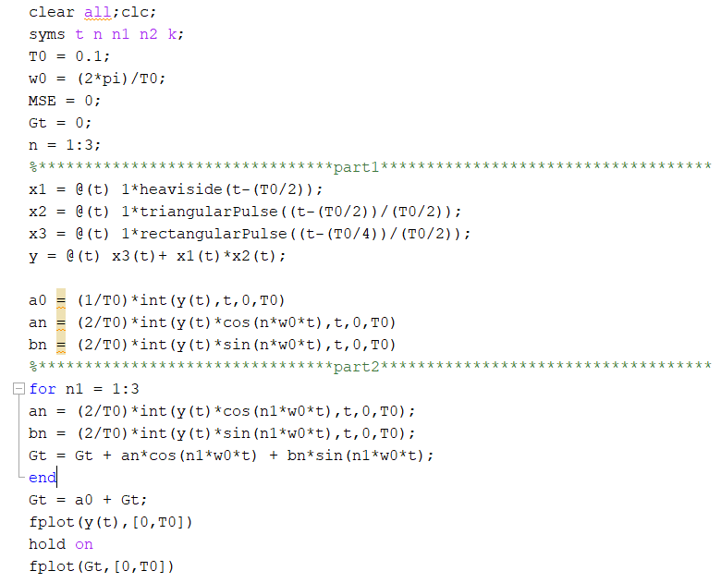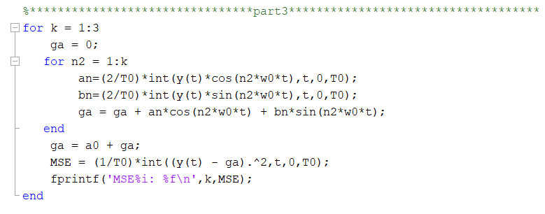

1

The Equation:

-In the first I find the general equation of the graph, by the signals:

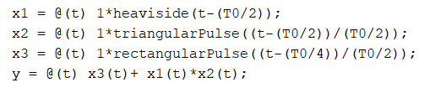

And this help my to start with the first part.

Part 1:



-in this part I find the a0,an values and bn values by this equations:

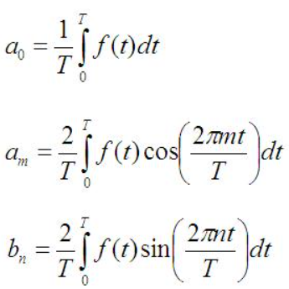

Then I converted them with matlab code with n[1:3]:

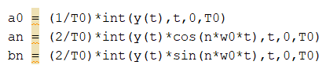

The results:

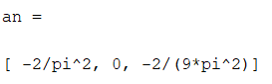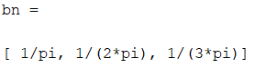 2

Part 2:



-In the part , I find the value of ga(t) for k = 3 :

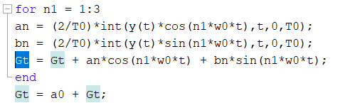

Then I plot it with one period of the original signal:

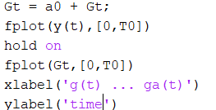

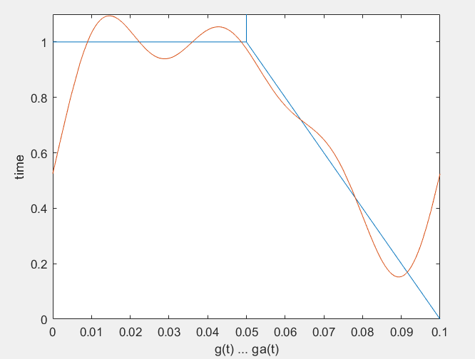

3

Part 3:

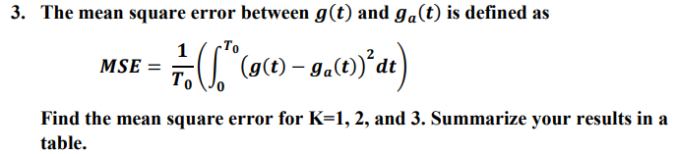

-In this part ,I find the value of ga(t) with k=1,k=2,and k=3, and in every time I find the main square error for each value if k with this code:

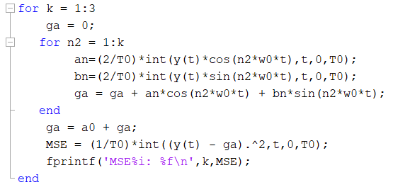

And if find this values if MSE:

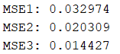

|  |  |
| --- | --- |
| K | MSE |
| 1 | 0.032974 |
| 2 | 0.020309 |
| 3 | 0.014427 |

4

Part 4:

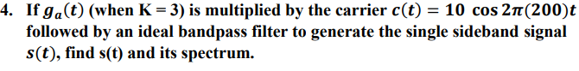

-In this part I find s(t) values with paper solution of it:

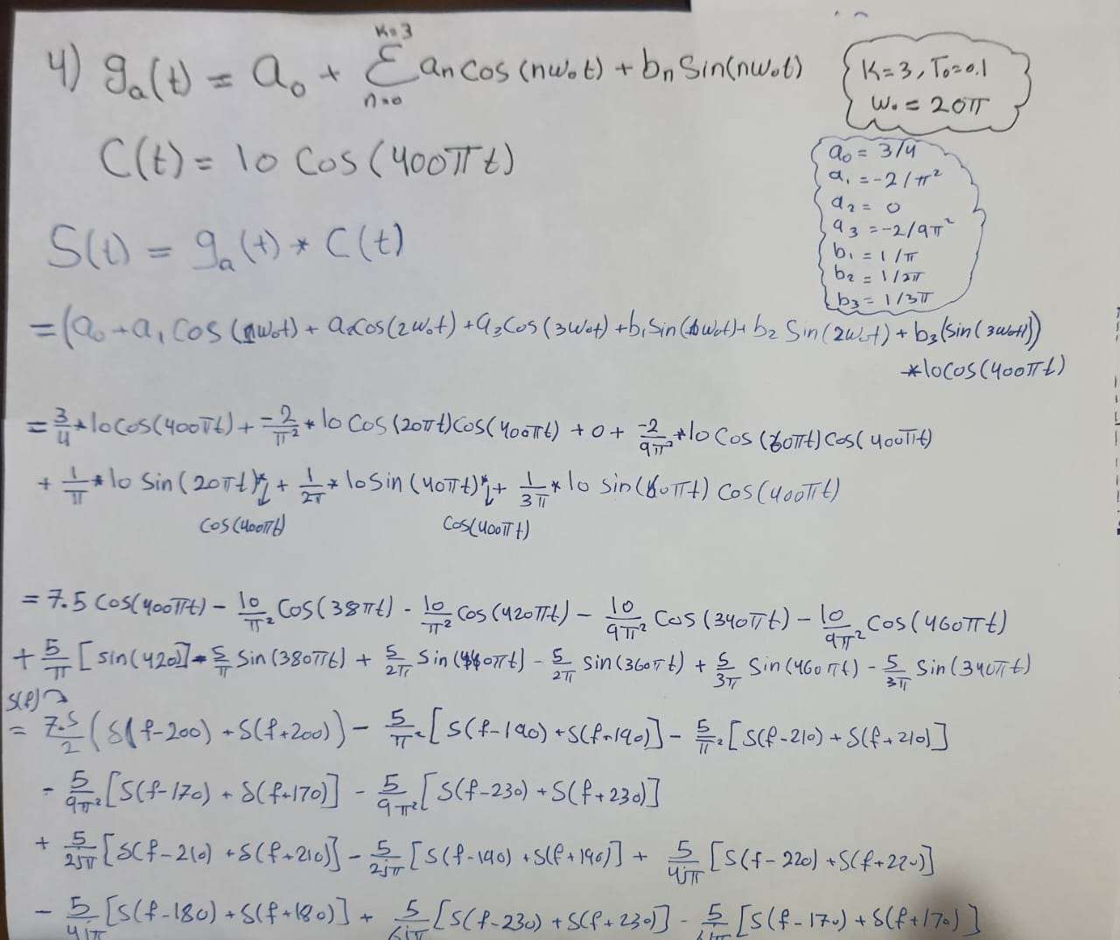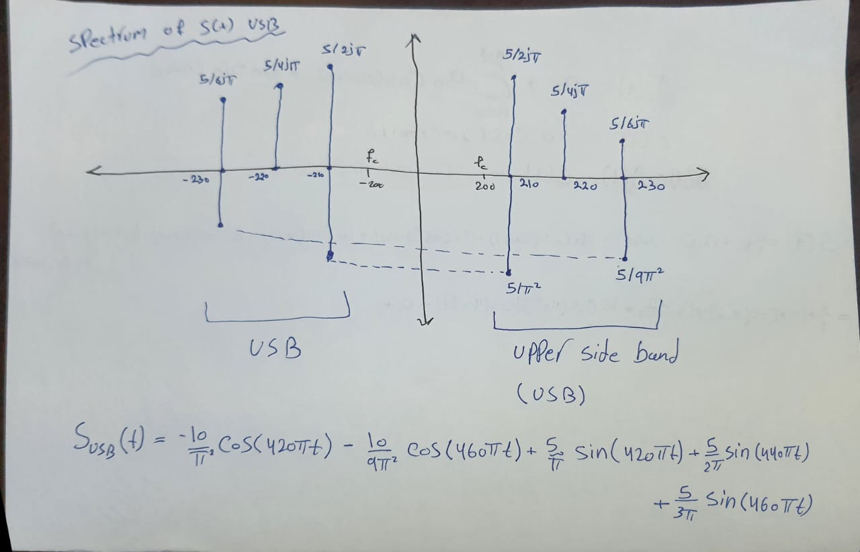The BW = 30Hz 5